NodeMCU Getting Started and Web Server Application

Introduction
NodeMCU is an open source firmware and development platform that helps you to develop rapid prototypes for IoT based applications etc. You can use Lua programming language to write apps but now there is arduino sketch support for NodeMCU. Of course behind the arduino there is a huge communities, supporters etc. Thus we will use arduino sketch in applications.

Installation for windows
NodeMCU includes CH340G USB-UART converter to communicate with computer. First you should install required driver for CH340G. Here you can download driver for CH340G. Also as you know the given links in the document could be broken in a time. Thus you could be search them in the internet if they broken.
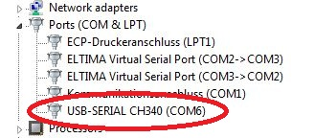

Figure 1
After driver installation as you see at figure 1 the new serial port connection(COM6) gonna occur on your computer. That's it! Now your computer ready to use NodeMCU.

Arduino sketch installation and NodeMCU implementation
If you don"t have arduino sketch in your computer you can install here.
After installation you should follow few steps they are listed below:
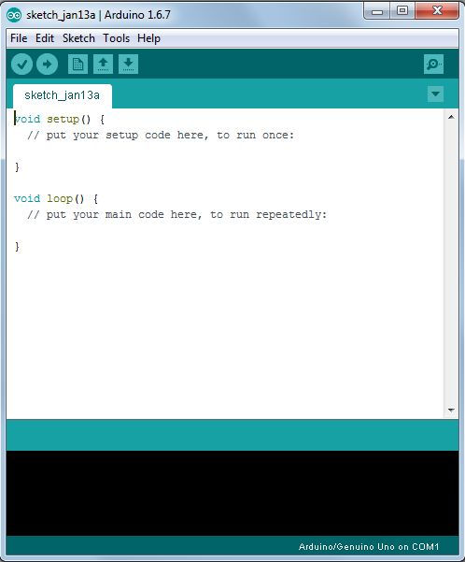
-Run Arduino Sketch

Figure 2
- Go to File --> Preferences menu and add the link
http://arduino.esp8266.com/versions/2.0.0/package_esp8266com_index.json
to the Additional Boards Manager URLs. Also you can seperate URLs by placing comma between them.
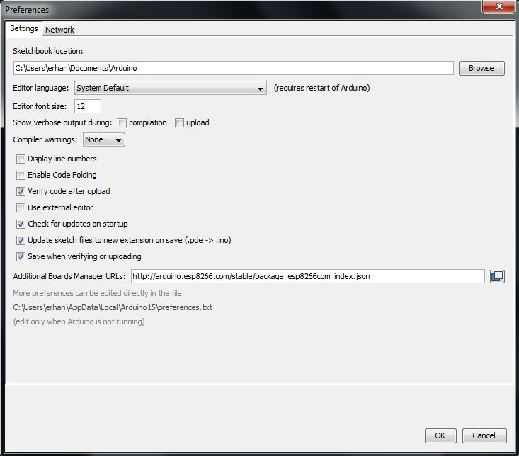

Figure 3
- Go to Tools --> Board --> Boards manager
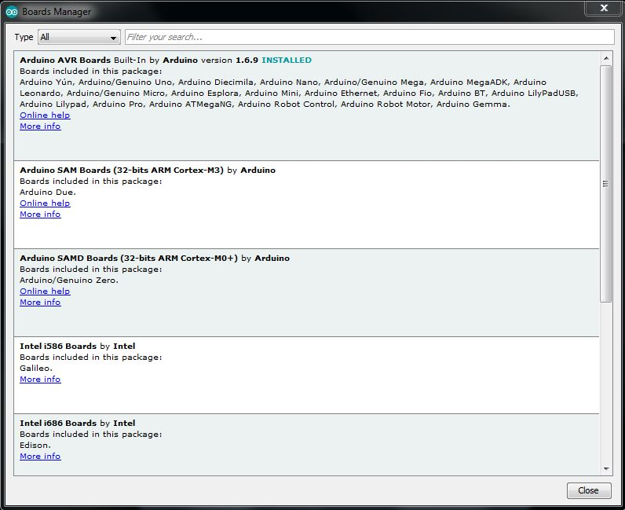

Figure 4
- Now you should have ESP8266 support. Search for ESP8266 and install it.
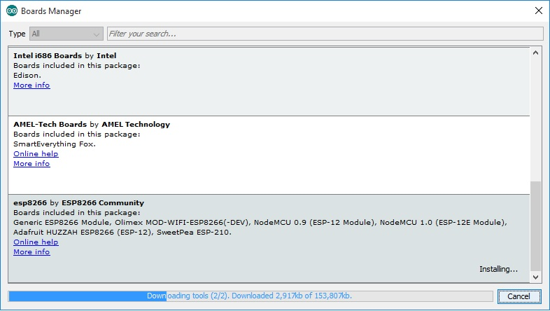
Figure 5

- Go to Tools --> Board and select proper NodeMCU board that you have.
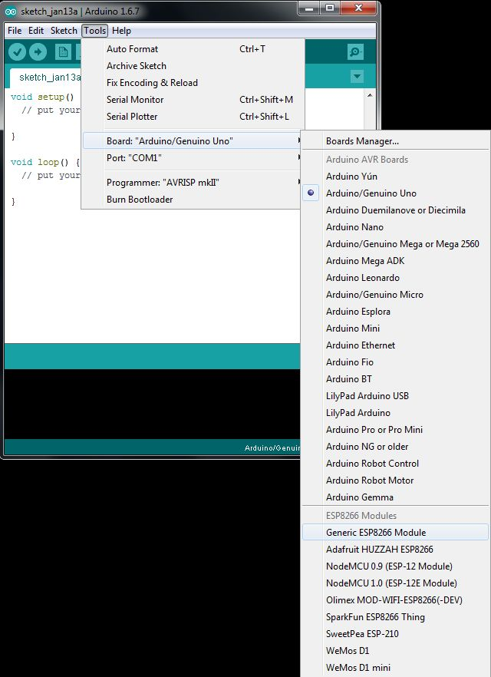

Figure 6
- Go to Tools --> Port and select port to connect NodeMCU.
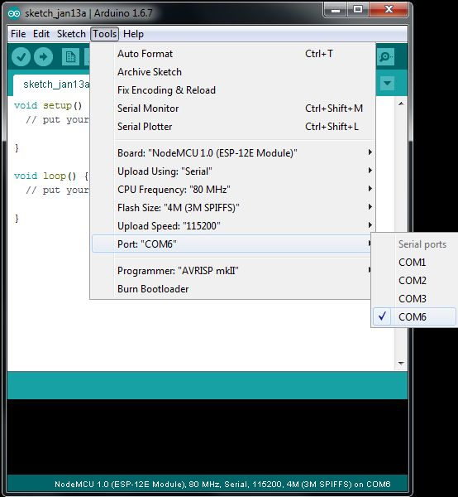

Figure 7
Congratulations! You are ready to write code for NodeMCU with arduino sketch. You can check example codes from File --> Examples menu.
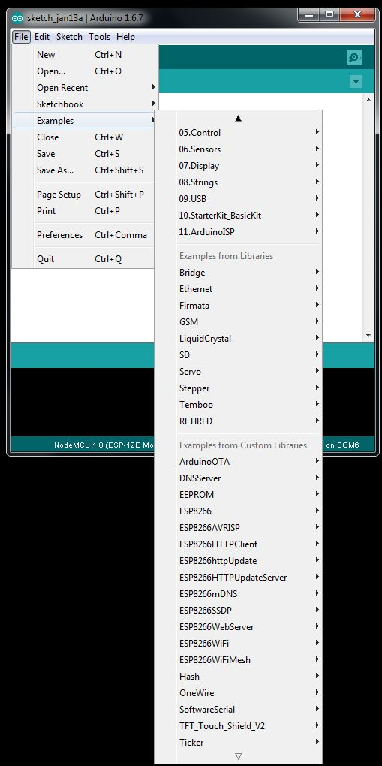

Figure 8
NodeMCU Pinout
ESP8266 useful SOC for WiFi applications. Also it includes many interfaces such a UART, SPI, SDIO and GPIOs. Below you can see available GPIO and interface pins for NodeMCU V3
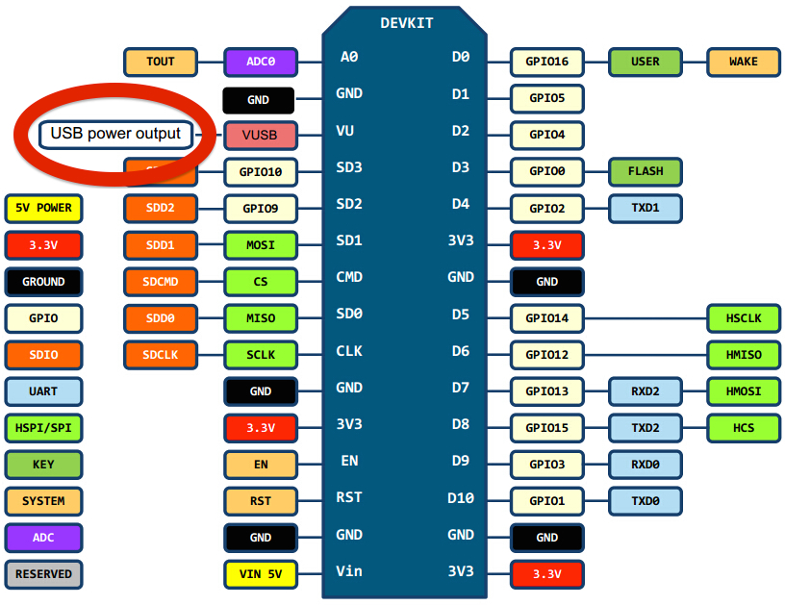
Figure 9
As you can see board pin names different then colored tags in the figure 9. So you should use this tag names when you are writing code for arduino. Below there is a simple code to read and write GPIOs

void setup()
{
pinMode(4, OUTPUT); // Initialize the GPIO4 pin as an output
pinMode(5, INPUT); // Initialize the GPIO5 pin as an input
}

void loop()
{
if (digitalRead(5) == HIGH) // If the GPIO5 state is HIGH
digitalWrite(4, HIGH); // Turn GPIO4 high
else // If not
digitalWrite(4, LOW); // Turn GPIO4 low
}
Web Server Application
As you know servers are big and expensive systems. These are serve us web sites, audios, videos, files etc. When you need simple web server to control few I/Os or to show some measured sensor data to user instead of expensive sytems you can use ESP8266 based NodeMCU board. Of course you can do so many internet, WiFi or IoT based applications with NodeMCU. Here we will do simple web server application with NodeMCu to see it's usefulness.

- Web Site Design
First you should design simple web site to show users. We assume that you have basic knowledge about html, java script etc. Even if you don't have knowledge don't worry the web site code is easy to understand and just one html file includes alll. You can see web page below.

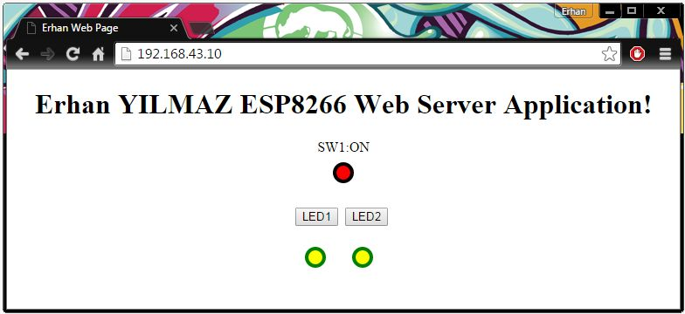
Figure 10
As you see on the figure 10 the web page consists of few objects, buttons and some texts. For test application we use 2 LEDs to control and 1 push button button to read. Thus we will have send and get data between NodeMCU based server and client. Here client is your web browser that you use for test. Below also you can see web page html codes. Because of the web page codes should be putted to arduino codes I didn't use any comment or so much space or tabs to reduce code size.

<!DOCTYPE html>
<html>
<head>
<title>Erhan Web Page</title>
<script>
var led1, x1, led2, x2;

function GetSwitchState()
{
nocache = led1 + led2 + "&nocache="+ Math.random() * 1000000;
var request = new XMLHttpRequest();
request.onreadystatechange = function(){

if (this.readyState == 4) {
if (this.status == 200){
if (this.responseText != null){

if (this.responseText.indexOf("LED1ON") > -1){
document.getElementById("LED1").style.fill = "yellow";}
else{
document.getElementById("LED1").style.fill = "black";}

if (this.responseText.indexOf("LED2ON") > -1){
document.getElementById("LED2").style.fill = "yellow";}
else{
document.getElementById("LED2").style.fill = "black";}

if (this.responseText.indexOf("S1:ON") > -1){
document.getElementById("SW1").style.fill = "red";document.getElementById("text1").innerHTML ="SW1:ON";}
else{
document.getElementById("SW1").style.fill = "white"; document.getElementById("text1").innerHTML ="SW1:OFF";}
}}}

}

request.open("GET", "ajax_switch" + nocache, true);
request.send(null);
setTimeout('GetSwitchState()', 1000);
}

function SetLEDStates(num)
{
switch(num)
{
case 1: if(x1==1){led1="&LED1ON";x1=0;}else{led1="&LED1OFF";x1=1;}break;
case 2: if(x2==1){led2="&LED2ON";x2=0;}else{led2="&LED2OFF";x2=1;}break;
case 0: led1="&LED1OFF";x1=1; led2="&LED2OFF";x2=1; break;
}
}
</script>
</head>

<body onload="GetSwitchState();SetLEDStates(0);">
<center>
<h1>Erhan YILMAZ ESP8266 Web Server Application!</h1>
<div id="text1"></div>
<svg width="40" height="40"><circle id="SW1" cx="20" cy="20" r="10"stroke="black" stroke-width="4" fill="white"/></svg>
<div id="text2"></div>
<p><button type="L1" onclick="SetLEDStates(1);">LED1</button>&nbsp;
<button type="L2" onclick="SetLEDStates(2);">LED2</button>&nbsp;</p>
<p><center>
<svg width="50" height="50"><circle id="LED1" cx="20" cy="20" r="10"stroke="green" stroke-width="4" fill="black"/></svg>
<svg width="50" height="50"><circle id="LED2" cx="20" cy="20" r="10"stroke="green" stroke-width="4" fill="black"/></svg>
</center></p>
</center>
</body>
</html>

- Arduino Codes and Running of Application
Web server application codes written in C++ with Arduino sketch. If you have used it before you can understand codes easily. Before compiling codes you should text your wifi ssid name and password.
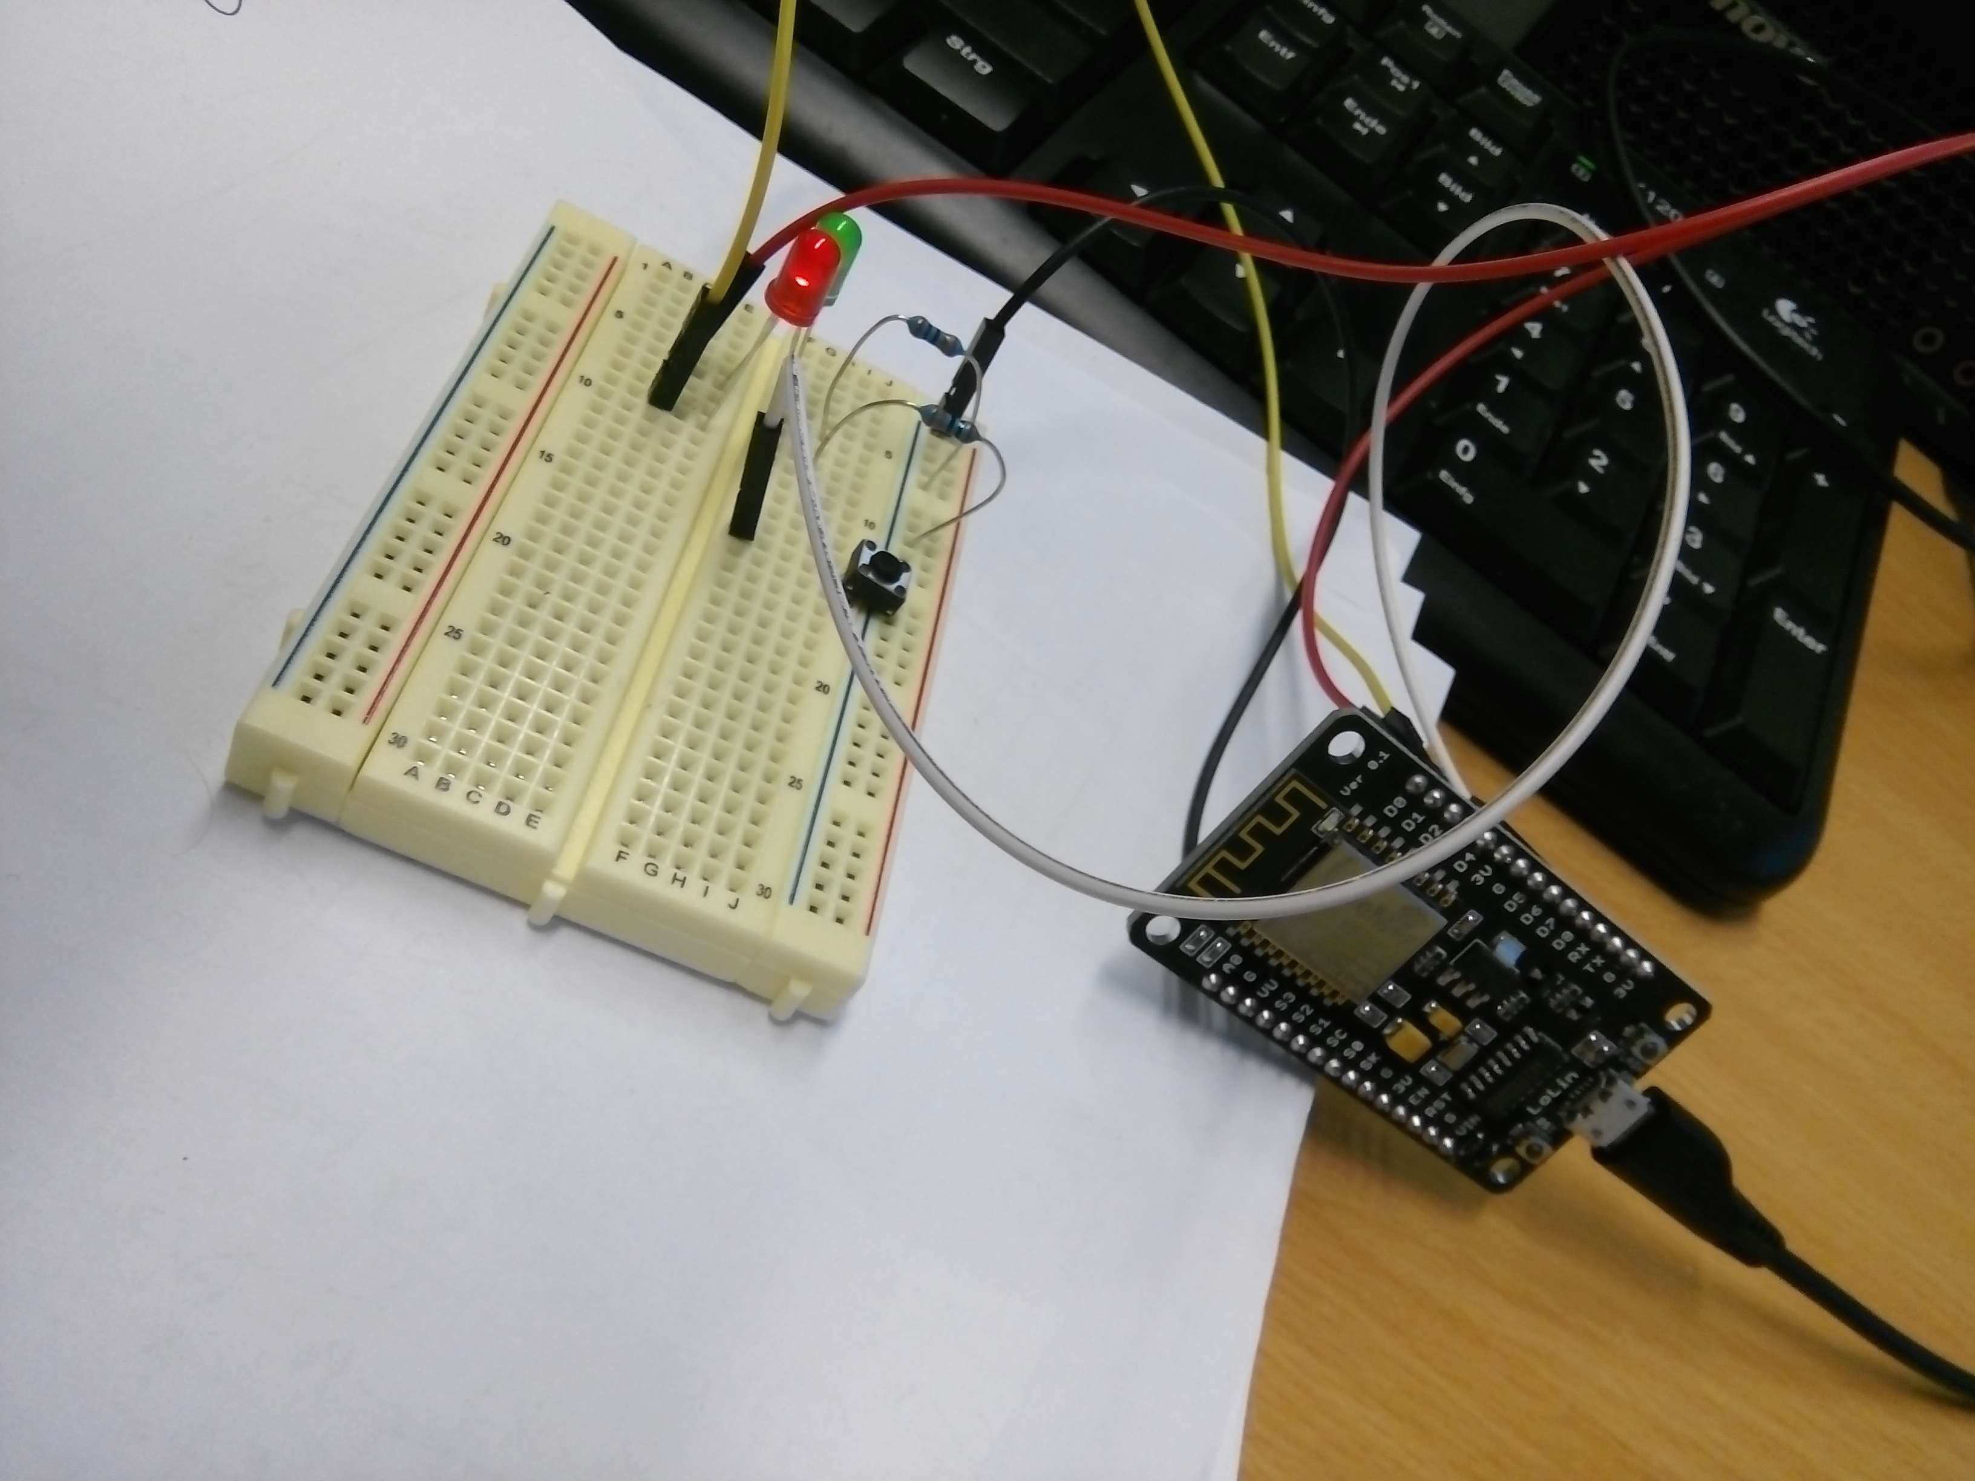
Figure 11
After loading program to ESP82266 when you power it up, it is gonna try to connect your wifi network. Also you can monitoring running logs via uart. After connection it is gonna take IP number automatically. By texting this IP to your web browser you can see application web site like at figure 10. To test application functionality you can make simple circuit with 2 LEDs, 2 330 Ohm resistors and 1 push button as you see at figure 11.

When you push the button on the web site the LEDs status sould change on the bread board. Also when you push the button on the bread board status of SW and its color should change on the page.
Thus you can control LEDs and read button status by the web site. This is simple application to understand how can we make web server with ESP8266. You can develop it for better applications.

Results
As you can understand ESP8266 based NodeMCU board really nice and usefull development kit for internet based applications. Also with arduino support to develop applications becomes a easier as well. With this document you can start to using NodeMCU easily. Here on the Github page of application you can find all codes, images, and documents related with application. I wish that would be usefull for someones. Please fell free to give me a feedyback about applications.
Regards...

Erhan YILMAZ
January 2016, Berlin

